Company/ Client: NCOC N. V | Project: ESKENE WEST KARABATAN |  |  | Location: Sulphur Plant Tr.01
Tag No:  A1-332-VA-102 | Component examined | Material | SA516GR.70N | Work order: 27302570
Procedure No:  QP-11-UTT-Q01 REV 00 | Component examined | Día X Nominal Thickness | - | Probe Details
Manufacturing Code/Acceptance Standard: As per client specification | Component examined | Operating Temp | Ambient | Probe | OLYMPUS  D790  S/N: 1058416
Method: Contact | Reference Calibration Block Details | Block | Step wedge | Angle | 0º
Method: Contact | Reference Calibration Block Details | Range | (6.25 – 25) mm | Frequency | 5 MHz
Equipment: Olympus 38DLP S/N:171421601 | Reference Calibration Block Details | Accuracy | 0.3mm | size | 11 mm
Equipment: Olympus 38DLP S/N:171421601 | Reference Calibration Block Details | Temperature | Ambient | Crystal | Dual
Surface condition: Coated | Correction factors | N/A |  | Reference sensitivity | 2nd backwall reflection to 80% FSH
Couplant: Gel | Correction factors |  |  | Scan Sensitivity | Reference dB
Job Description:
- UT has been carried out on selected location and spot reading taken. More info in section Details and Results.
- Inspection done on Painted Surface.
- Inspection done on External surface of the vessel.

Legend:
FSH: Full Screen Height, N/A: Not Applicable

DETAILS AND RESULTS
Observed Thickness:

S/NO | Item description | DIA(Ø) | Nominal WT | East | West | North | South | Top | Bottom | Centre
1 | Section 1 (Head) | 3442mm | 21.0 | - | - | 23.44 | 24.28 | 24.38 | 23.98 | 23.83
2 | Section 2 (Shell) | 3442mm | 21.0 | - | - | 22.03 | 22.87 | 22.82 | 23.05 | -
3 | Section 3 (Shell) | 3442mm | 21.0 | - | - | 21.75 | 21.67 | 22.10 | 21.84 | -
4 | Section 4 (Head) | 3442mm | 21.0 | - | - | 24.44 | 24.61 | 24.52 | 24.52 | 23.86
5 | Section 5 (Boot Shell) | 534mm | 17.0 | 17.85 | 18.21 | 18.03 | 18.07 | - | - | -
6 | Section 6 (Boot Head) | 534mm | 14.1 | 18.43 | 17.65 | 18.15 | 17.42 | - | - | 16.70
7 | Nozzle N1 | 6” | 10.97 | - | - | 11.70 | 11.57 | 11.14 | 11.47 | -

A1-332-VA-102

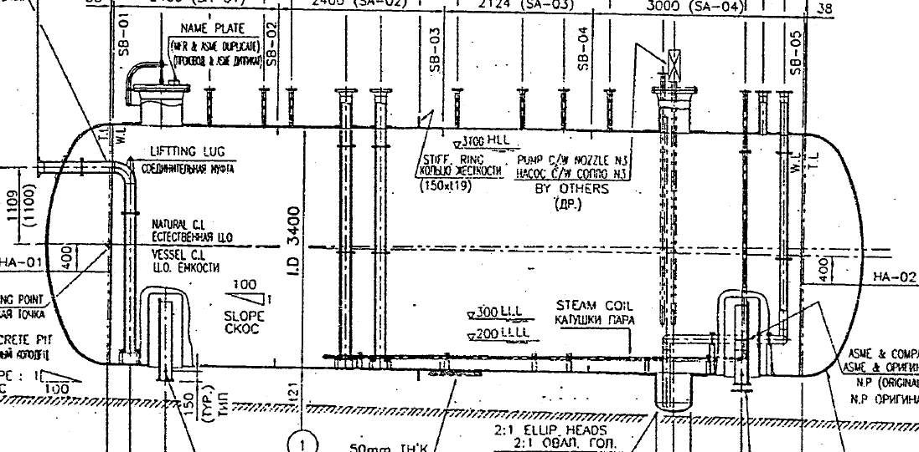

N1
Sec 1
Sec 2
East
side
Sec 4
Sec 3
West
side
Sec 5
Sec 6

Note: All readings taken on the painted surface.

All the dimension mentioned in mm.

DETAILS AND RESULTS
A1-332-VA-102

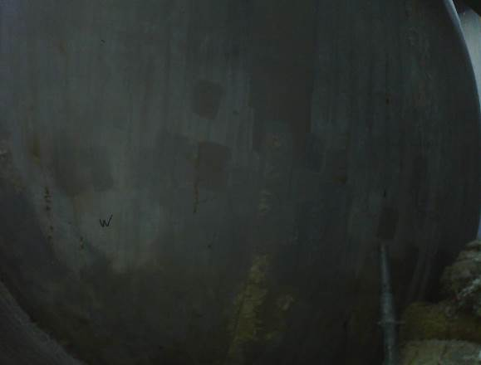
Section 1
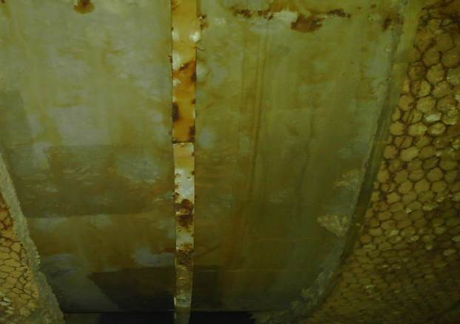
Section 2

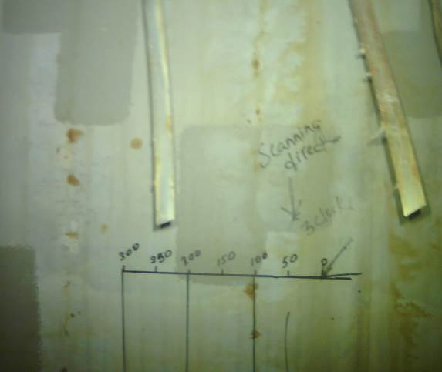
Section 3
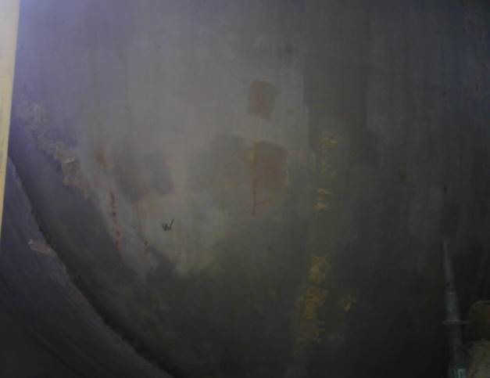
Section 4

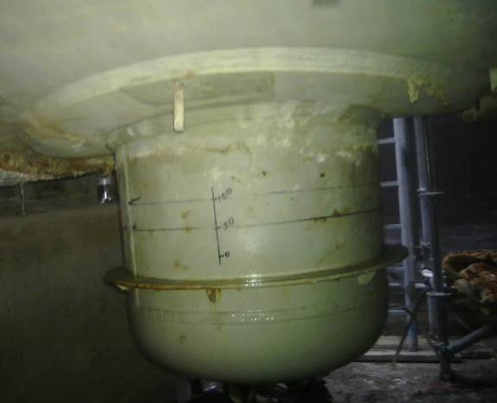
Section 5
Section 6

DETAILS AND RESULTS
Thickness Observed on Raster scanning:
A1-332-VA-102

S/NO | Item description | Nominal Thickness | Min | Max
1 | Boot Head | 14.1 | 15.7 | 17.6
2 | Vessel head 1 | 21.0 | 23.6 | 24.9
3 | Vessel head 2 | 21.0 | 24.3 | 24.8

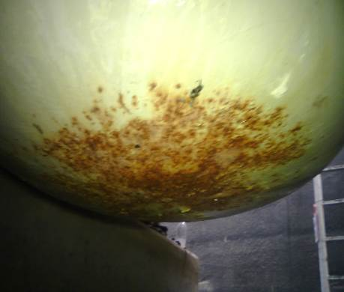
UT Scanning area
1
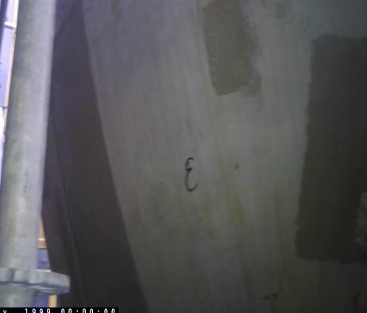
2
UT Scanning area
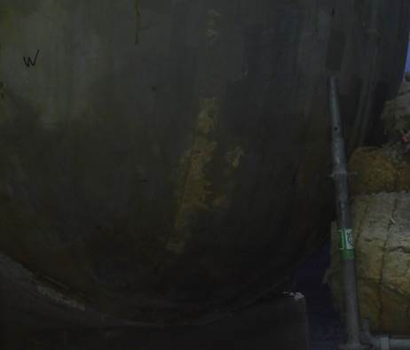
3
UT Scanning area

Note: All readings taken on the painted surface. Raster scanning has been done on Boot and bottom section of vessel head 1 & 2.

